Accord sur la Conservation des Cétacés de la mer Noire, de la Méditerranée et de la zone Atlantique adjacente, conclu sous l’égide de la Convention sur la Conservation des Espèces Migratrices appartenant à la Faune Sauvage (CMS)

Agreement on the Conservation of Cetaceans of the Black Sea, Mediterranean Sea and contiguous Atlantic area, concluded under the auspices of the Convention on the Conservation of Migratory Species of Wild Animals (CMS)
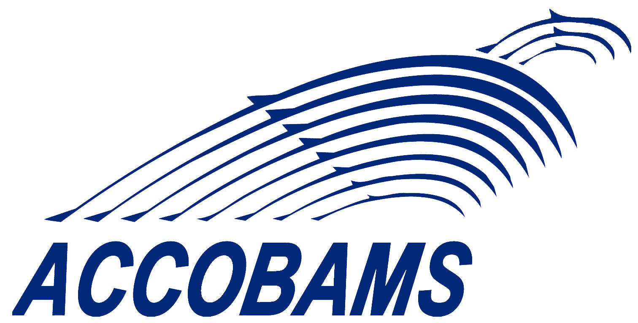
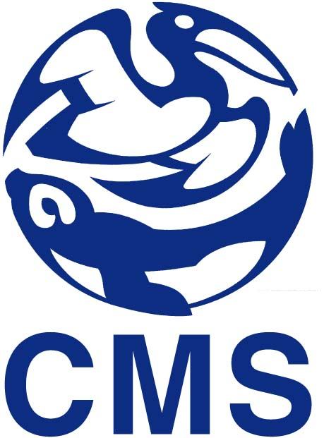

SEVENTEENTH MEETING OF THE ACCOBAMS SCIENTIFIC COMMITTEE

4 & 5 February 2026
The Nine Hotel - Tunis, Tunisia

REGISTRATION FORM

Please return this form no later than January 19th, 2026, to:
secretariat@accobams.net with copy to cmontiglio@accobams.net

Mr. Mrs. Ms.

Family Name:

First Name :

Entity:
Function:
Address:
Email:
Tel:
Mobile:
Dietary requirements:

