Accord sur la Conservation des Cétacés de la mer Noire, de la Méditerranée et de la zone Atlantique adjacente, conclu sous l’égide de la Convention sur la Conservation des Espèces Migratrices appartenant à la Faune Sauvage (CMS)

Agreement on the Conservation of Cetaceans of the Black Sea, Mediterranean Sea and contiguous Atlantic area, concluded under the auspices of the Convention on the Conservation of Migratory Species of Wild Animals (CMS)
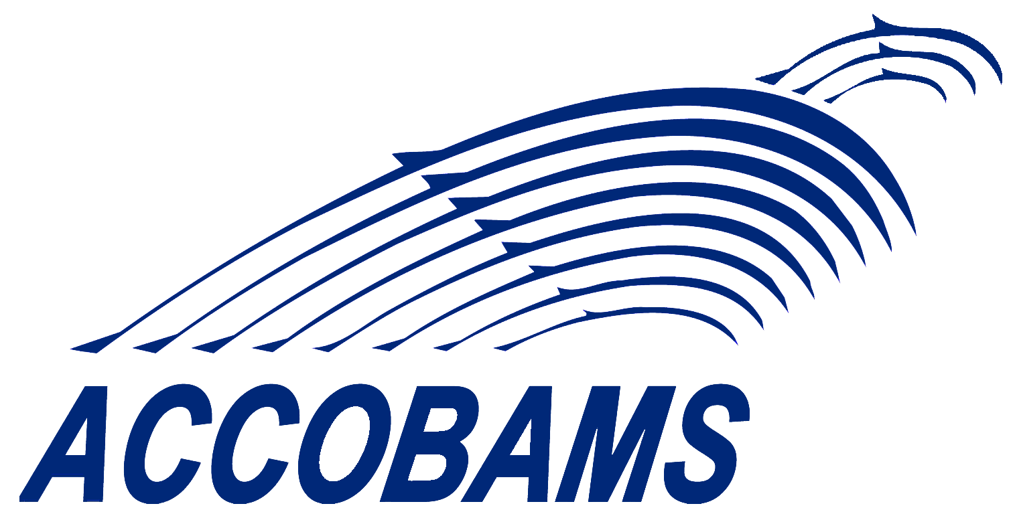
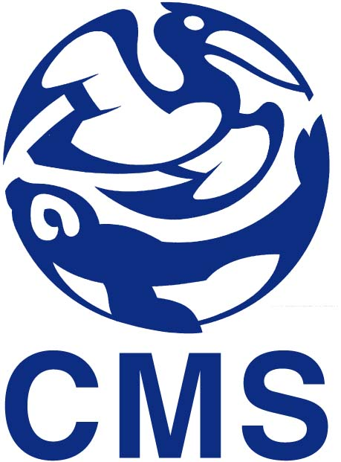

FIFTEENTH MEETING OF THE ACCOBAMS SCIENTIFIC COMMITTEE

10 & 11 May 2023
Tunis, Tunisia

REGISTRATION FORM

Please return this form no later than April 10th 2023 to:
cmontiglio@accobams.net with copy to secretariat@accobams.net

PARTICIPANT

M. Mrs. Ms.

Family Name:

First Name:

Entity:
Position:
Department:
Street:
Post Code:
City:
Country:
Email:
Tel: |  |  | Cell:

